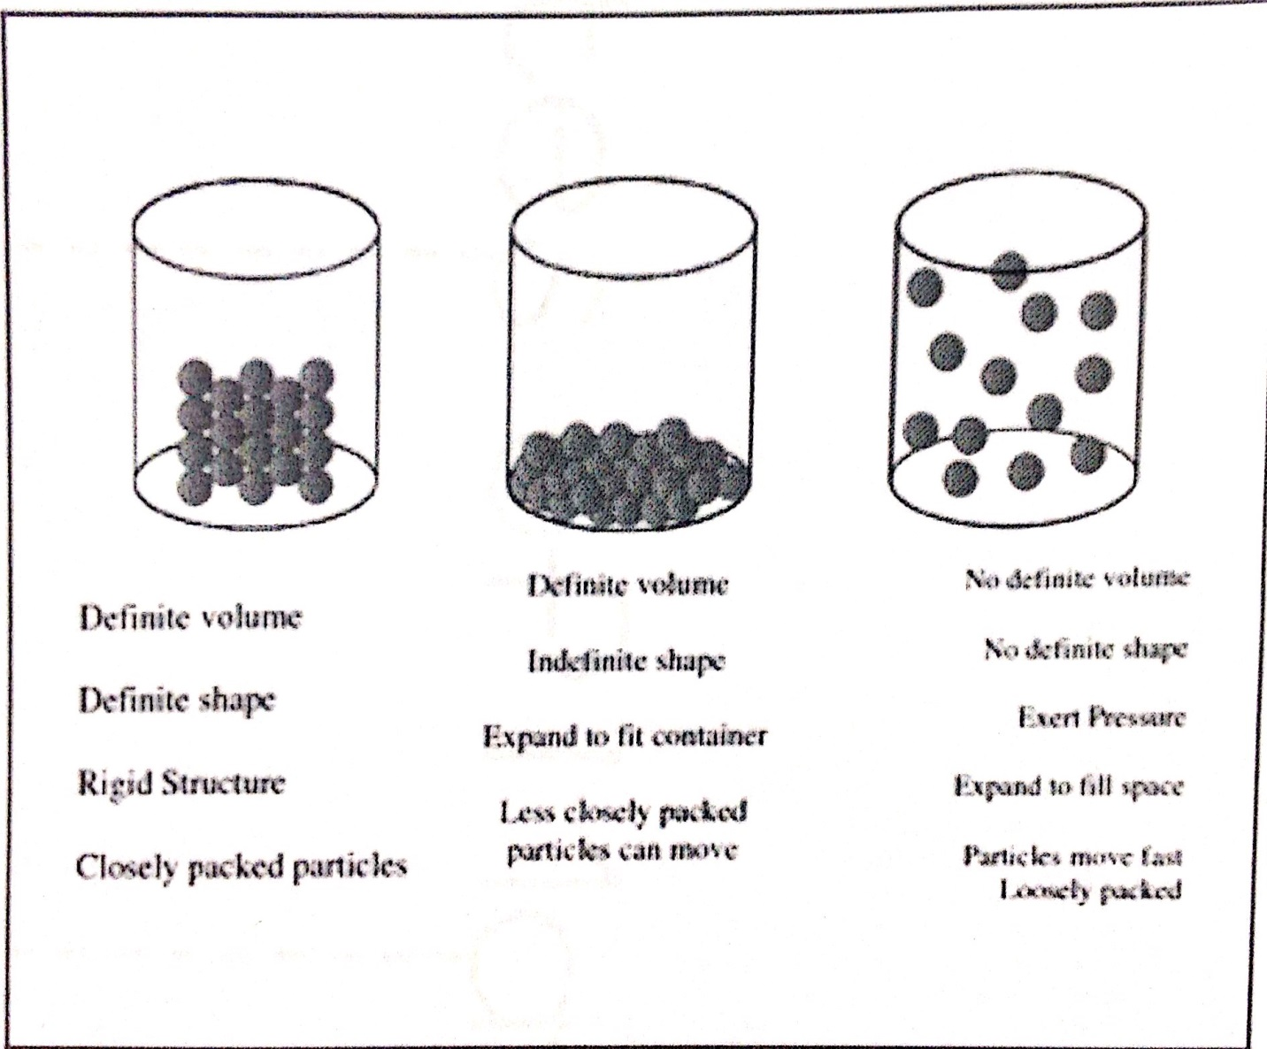
3
2
1.

Directions:
Name the three types of matter described above.

