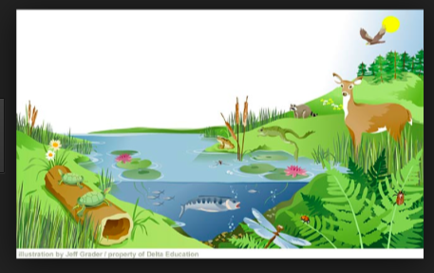

Science Starter for Thursday October 2, 2014
Create a t-chart in your Science Binder with the titles biotic and abiotic. Classify all the biotic and abiotic factors in the photo.

